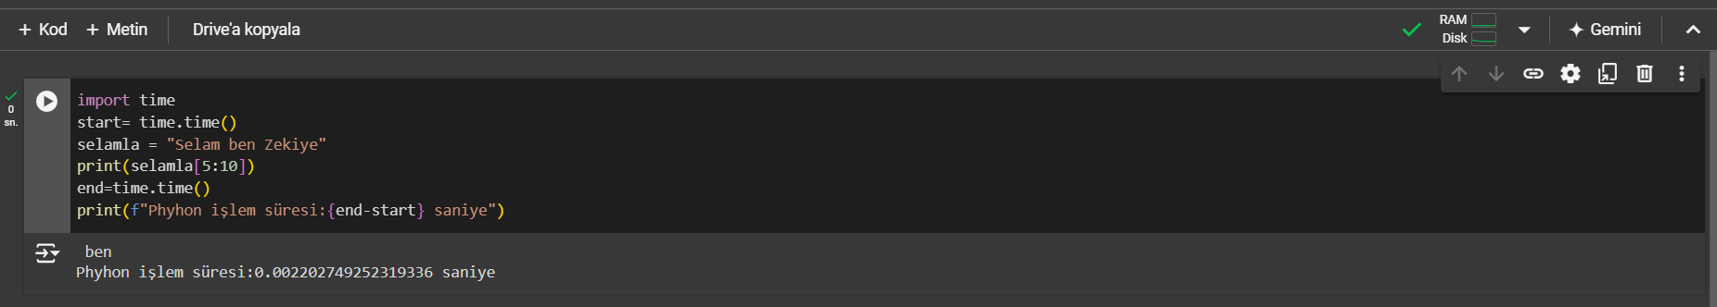

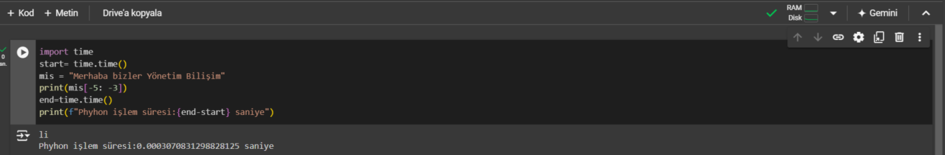

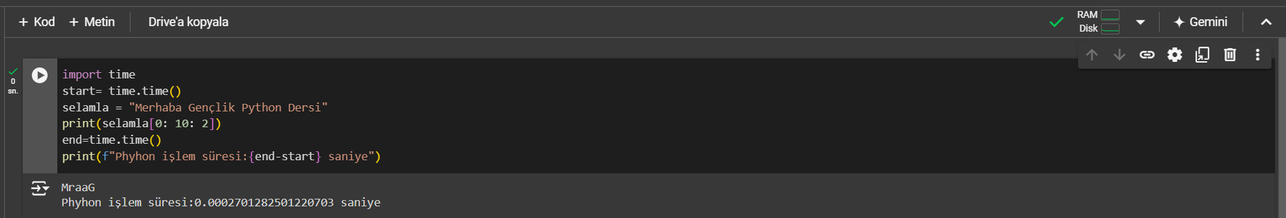

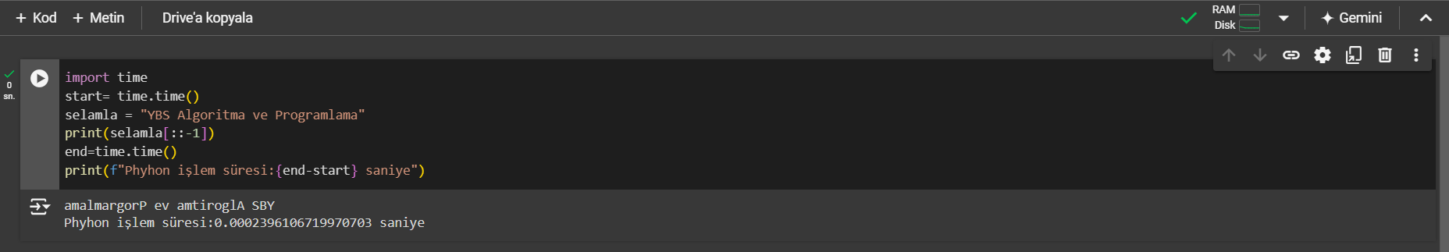

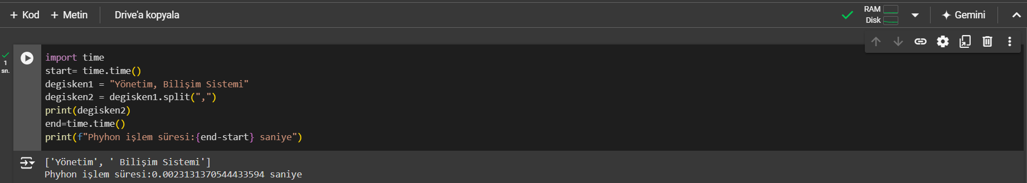

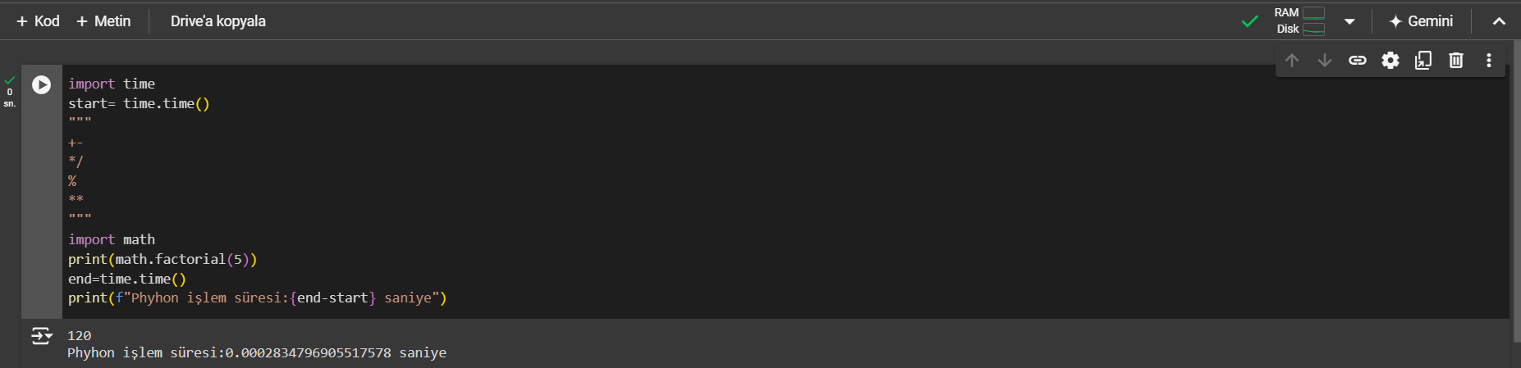

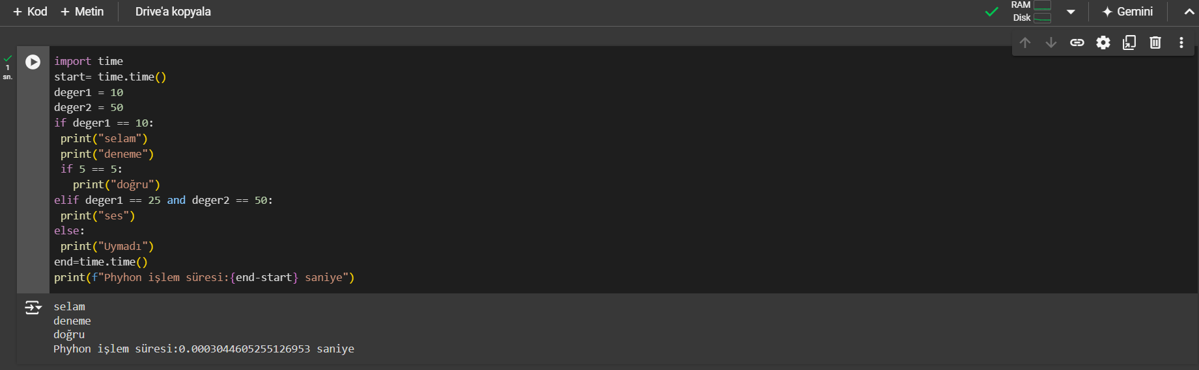

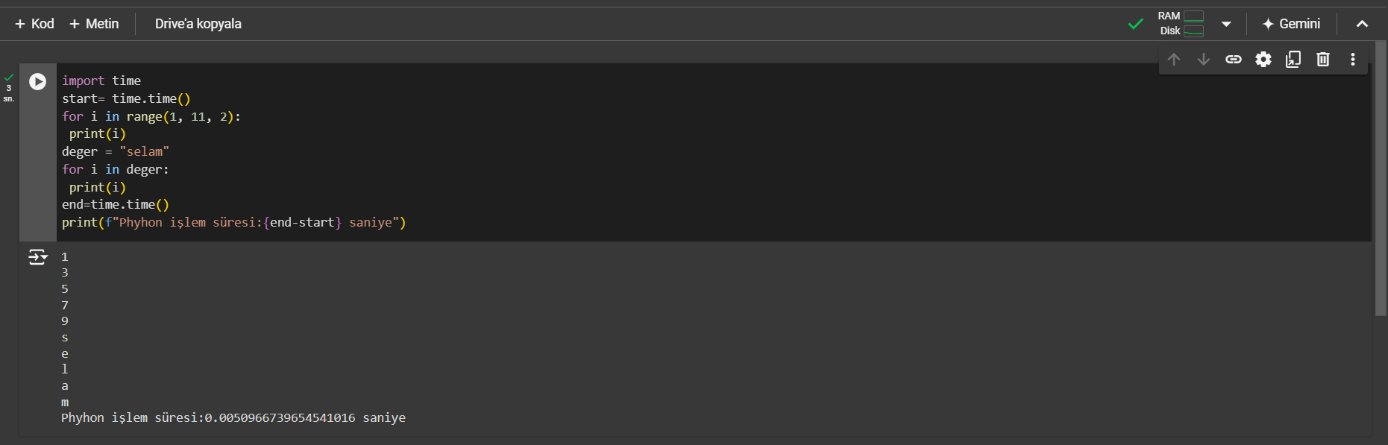

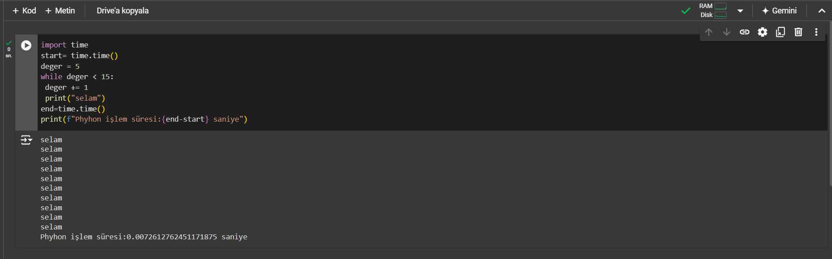

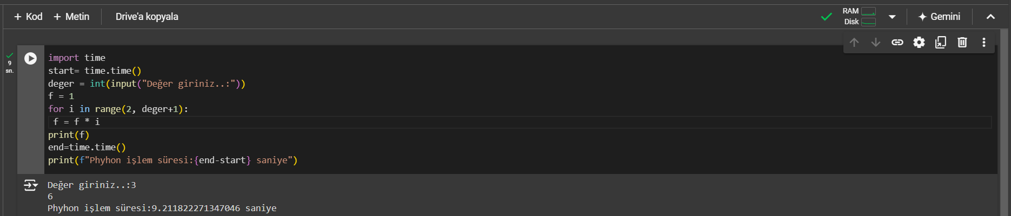

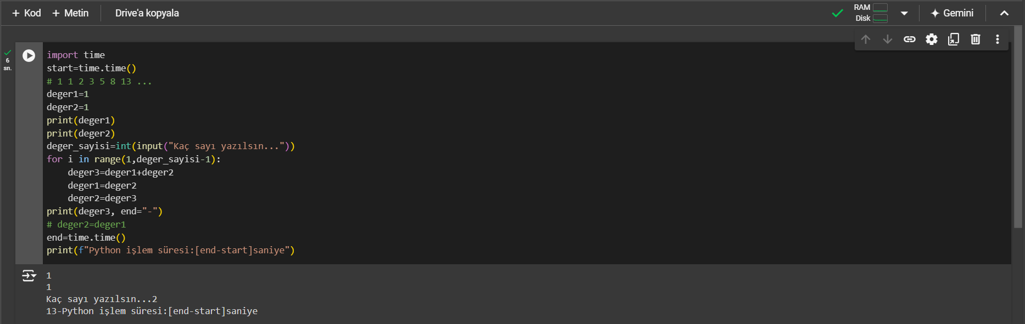

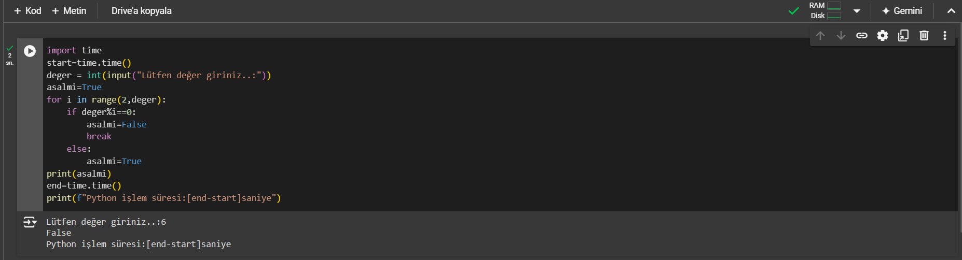

**ZEKİYE PINAR**

**48541317676**

**YBS 2. SINIF (İ.Ö)**